Set 12 – Website Traffic Analysis
Dataset: Website Traffic
Question 1: Create a line chart to visualize the trend in daily page views over time. Label the axes and title the chart.
Answer
A line chart is the natural choice for a measure tracked day by day, because the slope between points shows whether traffic is rising or falling.
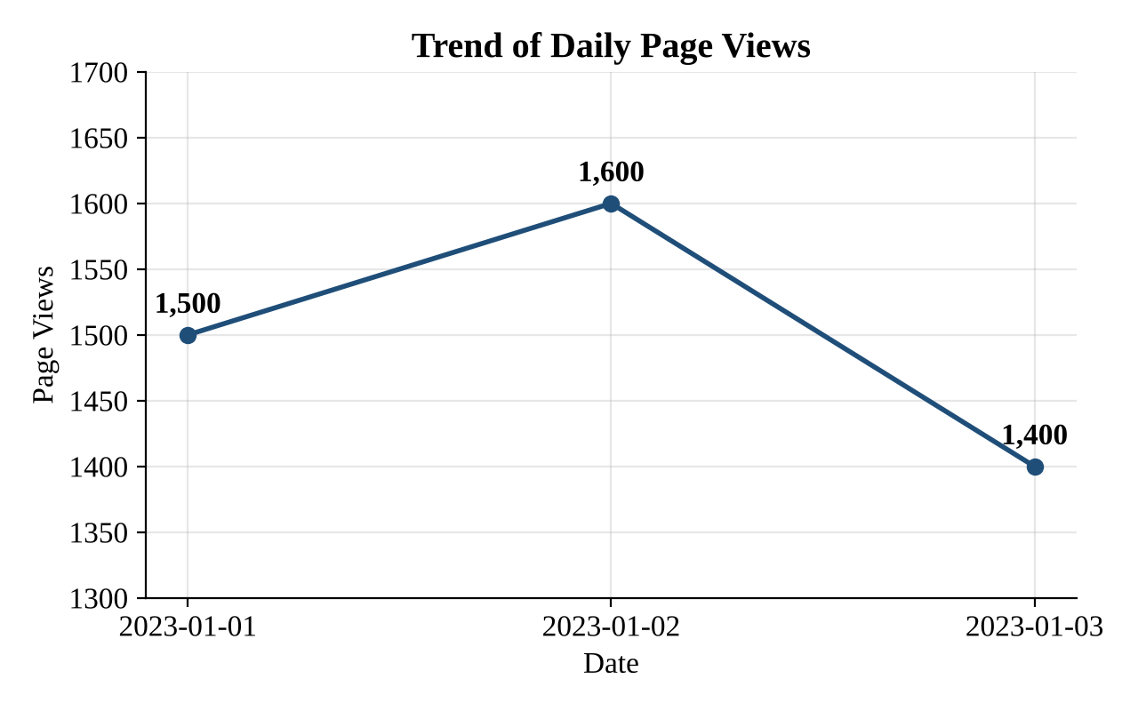
Figure 1: Line chart of daily page views
Chart elements
- Title: Trend of Daily Page Views
- X-axis: Date Y-axis: Page Views
- Observation: Page views rose from 1,500 to 1,600 (+6.7%) between 1 and 2 January, then fell to 1,400 (−12.5%) on 3 January. The peak day is 2 January and the lowest day is 3 January.
Tableau steps
- Drag Date to Columns (continuous day) and Page Views to Rows → Marks: Line; add Page Views to Label.

Set 12 – Website Traffic Analysis
Dataset: Website Traffic
Question 2: Generate a bar chart showing the top N days with the highest click-through rates. Label the chart elements.
Answer
The dataset contains only three days, so N = 3 is used and the days are ranked from the highest to the lowest click-through rate (CTR). In a larger dataset the same chart would be limited to the top N days.
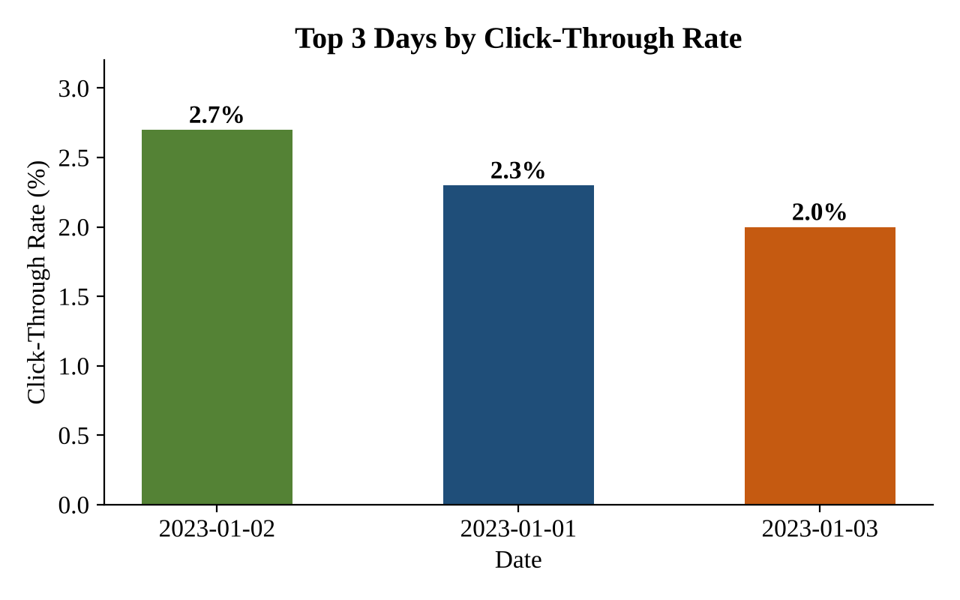
Figure 2: Bar chart of days ranked by click-through rate
Ranking
Rank | Date | Click-Through Rate
1 | 2023-01-02 | 2.7%
2 | 2023-01-01 | 2.3%
3 | 2023-01-03 | 2.0%

Chart elements
- Title: Top 3 Days by Click-Through Rate
- X-axis: Date Y-axis: Click-Through Rate (%)
Tableau steps
- Drag Date to Columns and Click-Through Rate to Rows → sort descending; right-click Date → Filter → Top tab → By field → Top N (e.g., 3) by Click-Through Rate.

Set 12 – Website Traffic Analysis
Dataset: Website Traffic
Question 3: Build a table to show the website traffic data for each day. Label the table elements.
Answer
The table below lists the website traffic for each day, with every column labelled.
Date | Page Views | Click-Through Rate
2023-01-01 | 1,500 | 2.3%
2023-01-02 | 1,600 | 2.7%
2023-01-03 | 1,400 | 2.0%
Table 1: Daily website traffic data
Table elements
- Date – the day on which traffic was recorded (YYYY-MM-DD).
- Page Views – total number of pages viewed that day.
- Click-Through Rate – percentage of views that resulted in a click.
Summary statistics
Measure | Page Views | Click-Through Rate
Total | 4,500 | –
Average | 1,500 | 2.33%
Highest | 1,600 (2 Jan) | 2.7% (2 Jan)
Lowest | 1,400 (3 Jan) | 2.0% (3 Jan)

Tableau steps
- Drag Date to Rows and use Measure Names / Measure Values for Page Views and Click-Through Rate → Show Me → Text Table.

Set 12 – Website Traffic Analysis
Dataset: Website Traffic
Question 4: Develop a Tableau dashboard combining the line chart, bar chart, and the table for interactive exploration of website traffic data.
Answer – Dashboard layout
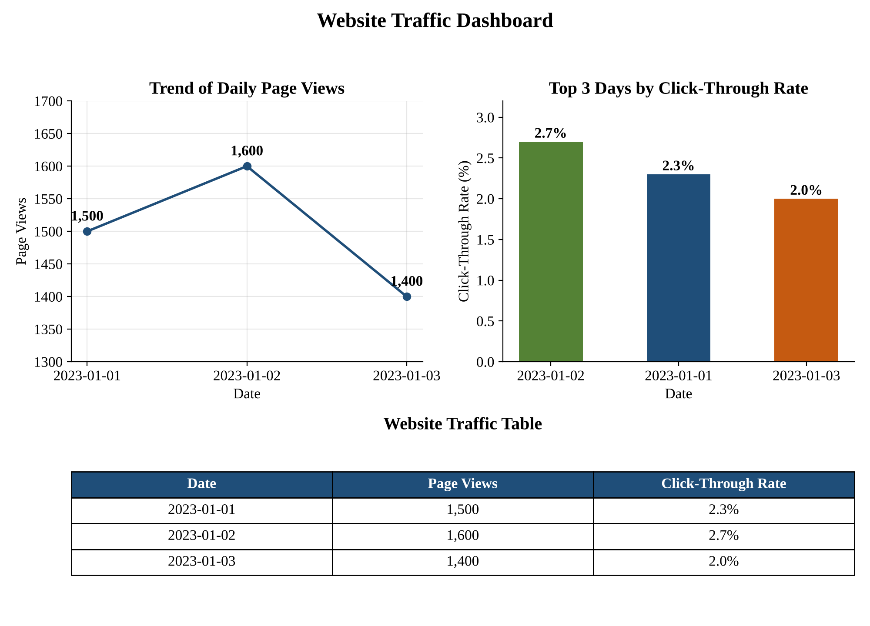
Figure 3: Website Traffic dashboard (line chart, bar chart and table combined)
Steps to build it in Tableau
Step 1. Create three worksheets: Daily Page Views, Top CTR Days and Traffic Table (Questions 1–3).
Step 2. Click New Dashboard; set Size to Automatic or Fixed (1000 × 800).
Step 3. Place the line chart and bar chart in the top row and the table in the bottom row.
Step 4. Enable ‘Use as Filter’ on both charts so selecting a day highlights or filters the other views and the table.
Step 5. Add a Date range filter and a Top N parameter (applied to all worksheets) and give the dashboard a title.
Step 6. Save/publish the workbook (Tableau Public or Server).

